The Talent Trouble MatrixTM is a tool you can use when you are feeling hopeful and yet vaguely uneasy about someone you are counting on.
Use the Talent Trouble Matrix to get quick clarity and a path forward.

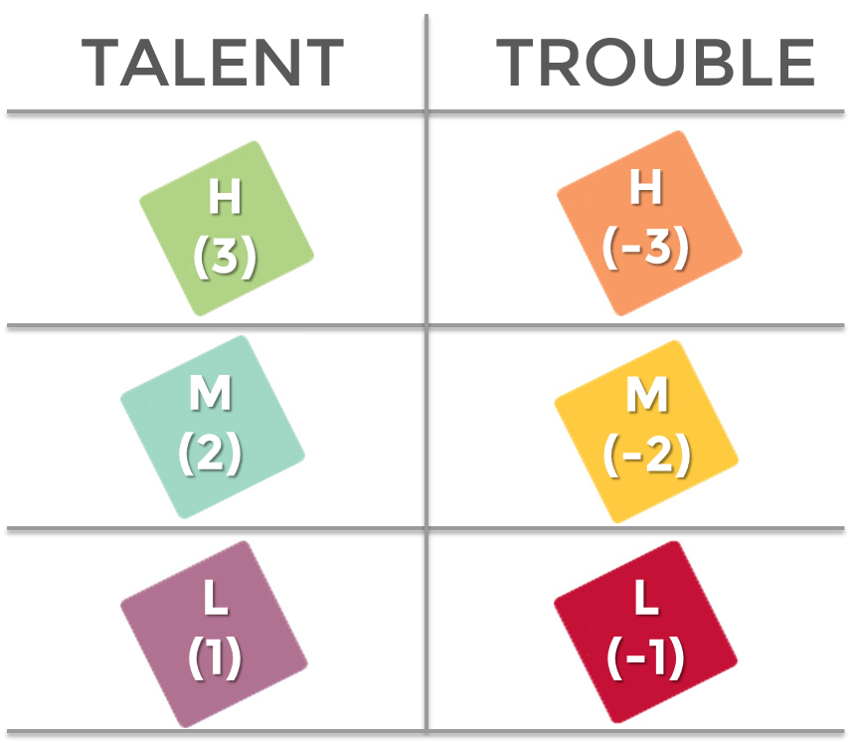

Talent Examples: Sheer Intellect, Specialized Expertise, Gifted with People, Passionate Drive, Absolute Tenacity, Practical Wisdom, Cut Through Problem Solving, Action Acceleration

Trouble Examples: Taking Too Much Risk, Poor Judgement, Unresolved Conflict, Unchecked Personal Needs, Stress Volatility, Not Taking Others Needs into Account, High Need to Win, Over Reliance on Core Talent

